You must add a *sing* method to the *Bird* class, then modify the *main* method accordingly so that the code prints the following lines:

I am walking

I am flying

I am singing

**class** Animal{

**void** walk(){

        System.out.println("I am walking");

    }

}

**class** Bird **extends** Animal{

**void** fly(){

        System.out.println("I am flying");

    }

**void** sing(){

        System.out.println("I am singing");

    }

}

**public** **class** Solution{

**public** **static** **void** main(String args[]){

      Bird bird = **new** Bird();

      bird.walk();

      bird.fly();

      bird.sing();

   }

}

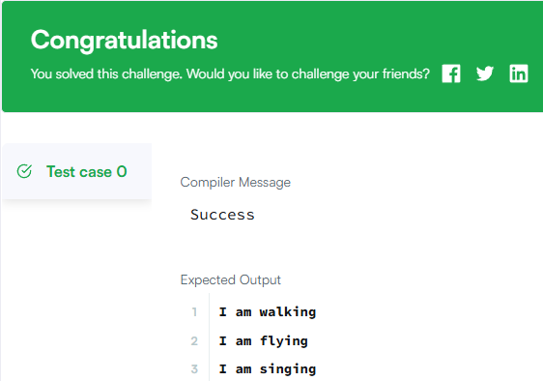

Write the following code in your editor below:

1. A class named *Arithmetic* with a method named *add* that takes 2 integers as parameters and returns an integer denoting their sum.
2. A class named *Adder* that inherits from a superclass named *Arithmetic*.

Your classes should not be public.

**import** java.io.*;

**import** java.util.*;

**class** Arithmetic {

**public** **int** add(**int** a, **int** b) {

**return** a + b;

    }

}

**class** Adder **extends** Arithmetic {}

**public** **class** Solution {

**public** **static** **void** main(String[] args) {

        Adder adder = **new** Adder();

        System.out.println("My superclass is: Arithmetic");

        System.out.println(adder.add(20, 22) + " " + adder.add(7, 6) + " " + adder.add(10, 10));

    }

}

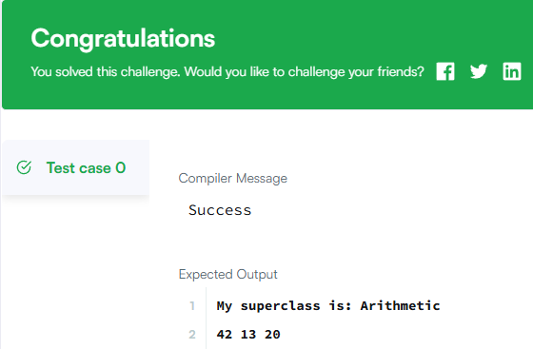

**Task**  
You are given two classes, *Person* and *Student*, where *Person* is the base class and *Student* is the derived class. Completed code for *Person* and a declaration for *Student* are provided for you in the editor. Observe that *Student* inherits all the properties of *Person*.

Complete the *Student* class by writing the following:

* A *Student* class constructor, which has 4 parameters:
  1. A string, **firstName**.
  2. A string, **lastName**.
  3. An integer, **idNumber**.
  4. An integer array (or vector) of test scores, **scores**.
* A *char* ***calculate()*** method that calculates a Student object's average and returns the grade character representative of their calculated average:

**import** java.util.*;

**class** Person {

**protected** String firstName;

**protected** String lastName;

**protected** **int** id;

**public** Person(String firstName, String lastName, **int** id) {

**this**.firstName = firstName;

**this**.lastName = lastName;

**this**.id = id;

    }

**public** **void** printPerson() {

        System.out.println("Name: " + lastName + ", " + firstName);

        System.out.println("ID: " + id);

    }

}

**class** Student **extends** Person {

**private** **int**[] testScores;

**public** Student(String firstName, String lastName, **int** id, **int**[] scores) {

**super**(firstName, lastName, id);

**this**.testScores = scores;

    }

**public** **char** calculate() {

**int** sum = 0;

**for** (**int** score : testScores) {

            sum += score;

        }

**int** avg = sum / testScores.length;

**if** (avg >= 90) **return** 'O';

**else** **if** (avg >= 80) **return** 'E';

**else** **if** (avg >= 70) **return** 'A';

**else** **if** (avg >= 55) **return** 'P';

**else** **if** (avg >= 40) **return** 'D';

**else** **return** 'T';

    }

}

**public** **class** Solution {

**public** **static** **void** main(String[] args) {

        Scanner scanner = **new** Scanner(System.in);

        String firstName = scanner.next();

        String lastName = scanner.next();

**int** id = scanner.nextInt();

**int** numScores = scanner.nextInt();

**int**[] scores = **new** **int**[numScores];

**for** (**int** i = 0; i < numScores; i++) {

            scores[i] = scanner.nextInt();

        }

        scanner.close();

        Student student = **new** Student(firstName, lastName, id, scores);

        student.printPerson();

        System.out.println("Grade: " + student.calculate());

    }

}

